VMAX/PMAX HARDWARE ARCHITECTURE
New features of VMAX3:
- All new HYPERMAX OS 5977 replaced with Enginuity 5876.
- Dynamic Virtual Matrix Architecture (DVM) — CPU pooling concept provides on-demand cores.
- 100% Virtually Provisioned — Factory pre-configured.
- Embedded NAS (eNAS).
- New TimeFinder SnapVX — Point-in-time replication technology.
- Other number of enhancements & Operational capacities has been increased.

SPECIFICATION BASED ON MODELS:
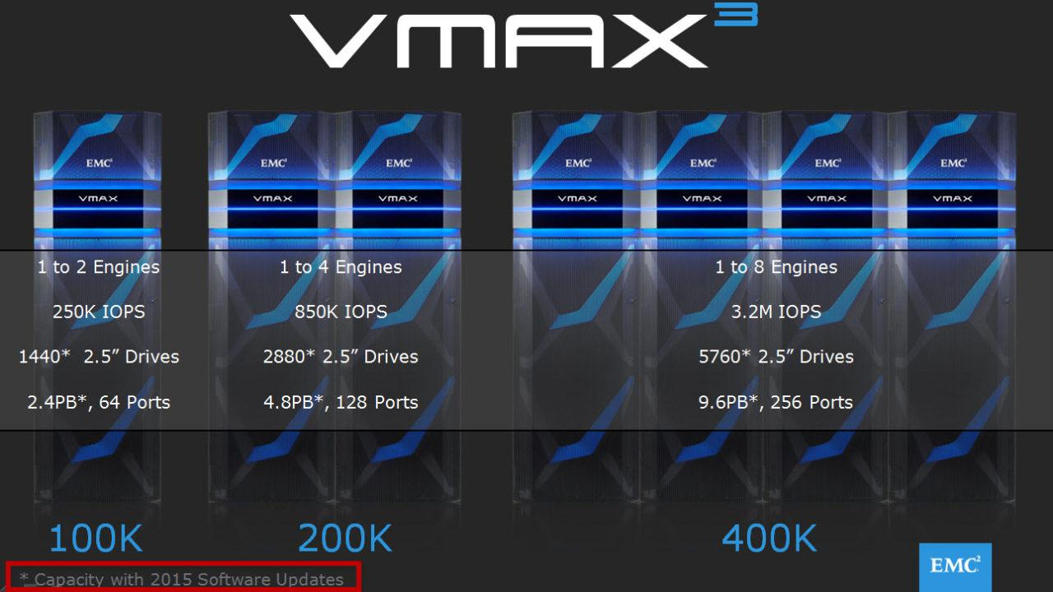

PICTURE OF VMAX 3 ENGINE:
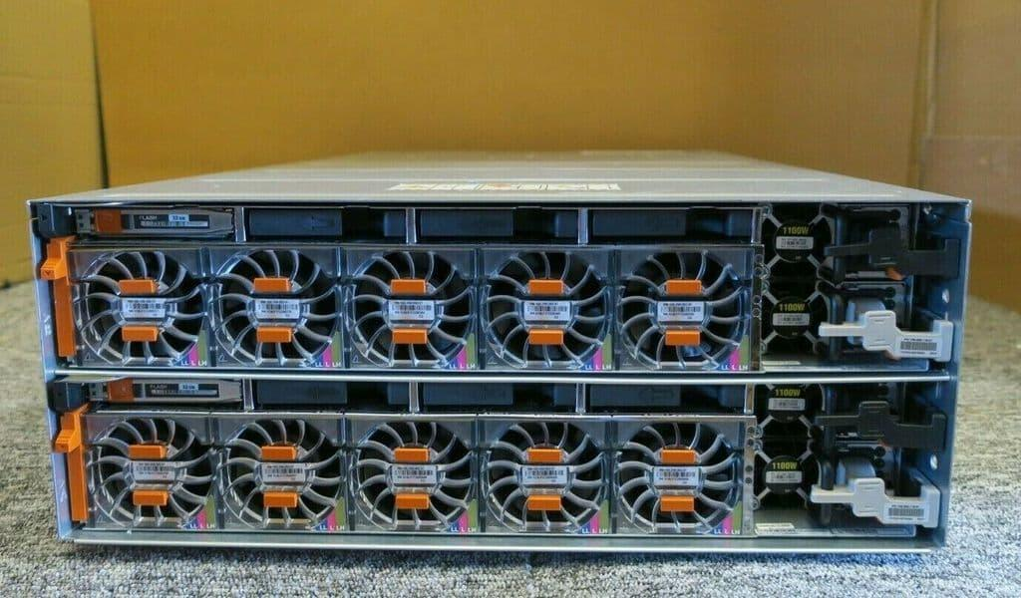

The above picture is one engine that has 2 directors in it namely DIR1 and DIR2.

The logical view of a VMAX 3 engine.
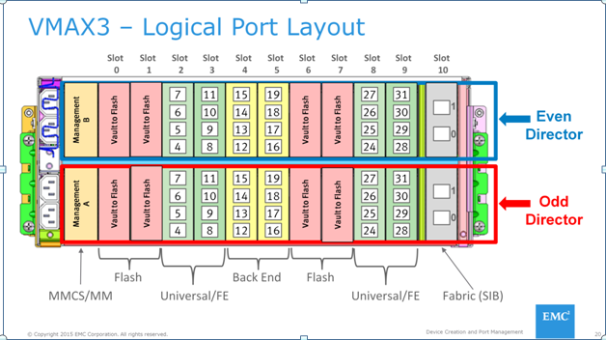
MMCS & MM: There are 2 types of management modules — Management Module Control Stations & standard Management Module (MM). The first engine of each system will be deployed with an MMCS in each director. Each subsequent engine (engines 2–8) will be deployed with a management module in each director, in place of an MMCS. MMCS combines the management module and control station (service processor) hardware into a single module.
MMCS functions:
- Environmental monitoring capabilities for power, cooling & connectivity.
- Each MMCS monitors one of the system standby power supplies (SPS) through a RS232 connection.
- Each MMCS is also connected to both internal Ethernet switches within the system.
- Provides support functionality. Each MMCS connects to LAN and remote connectivity for EMC support team.
- Can be connected to external laptop.
Management Module (MM): is a subset of MMCS, which does not include control station functionality. Each management module has an RS232 connection to an SPS. Management module A connects only to Ethernet switch A, and management module B connects only to Ethernet switch B and is responsible for monitoring and reporting.
Global memory technology overview:Global memory is a crucial component in the architecture. All read and write operations are transferred to or from global memory. Transfers between the host processor and channel directors can be processed at much greater speeds than transfers involved with physical drives. HYPERMAX OS uses complex statistical prefetch algorithms which can adjust to proximate conditions on the array. EMC intelligent algorithms adjust to the workload by constantly monitoring, evaluating, and optimizing cache decisions.
DDR3 DRAM technology (16 slots per director) allows the array to be configured up to 2TB of mirrored memory per engine, and up to 16TB mirrored per array.
Shared physical memory: Global memory is accessible by any director within the array.
- If an array has a single engine, physical memory pairs are internal to the engine
- If an array has multiple engines, physical memory is paired across engines
Dual-write technology is maintained by the array. In the event of a director or memory failure, the data continues to be available from the redundant copy.
Front-end connectivity:
The front-end I/O modules are used for channel connectivity. There are 32 ports (16Gbps) per engine. There are different types of front-end I/O modules that allow connectivity to various different interfaces. These include SAN, SRDF, and embedded NAS (eNAS).
SAS back-end connectivity:
The system’s architecture incorporates a 6 Gb/s SAS (Serial attached SCSI) back-end design to ensure high performance and full redundancy. SAS is a reliable, high end protocol that uses a connectionless tree structure with unique paths to individual devices. The paths are stored in routing tables which are built during a discovery phase and are used to route I/O to the desired end point.
The SAS back-end subsystem provides independent redundant paths to the data stored on physical drives. This provides seamless access to information, even in the event of a component failure and/or replacement.

What is Vaulting
Symmetrix VMAX systems are configured with vault drives on back-end Fibre Channel loops. Vaulting is the mechanism used to protect your VMAX data when:
1. powering down the array,
2. a power outage occurs or
3. in the event some environmental change such as an air conditioning failure occurs resulting in ambient temperature being exceeded (VMAX Operating temperature is 59-90F | 15 to 32C). On a failure of the array the SPS’s maintain power to the array for 300 Seconds, this allows the VMAX to write the data in global cache memory to the Vault devices and to shut down the array in a controlled manner. Two copies of the cache memory is written to independent vault devices allowing for a fully redundant Vault. Successfully writing all data in cache memory to Vault devices is very important in ensuring the consistency of application data stored on the VMAX.
How Vaulting Operates
1. The first part of the vault process is to stop all transactions to the VMAX. Once all the I/O is stopped the directors will then write all the global memory data to the vault devices. The shutdown of the VMAX will then be complete.
2. The second part of the vault process is restoring the cache memory from Vault. During this process, the array will re-initialize the physical memory, check the integrity of the data in Vault and then restore the data to the global cache. The VMAX resumes operation once the SPSs are sufficiently recharged to support another Vault operation.
Configuration Considerations
The following table lists the amount of dedicated vault space and number of devices that is required per engine for Vault across the three VMAX systems 10K/20K/40K:
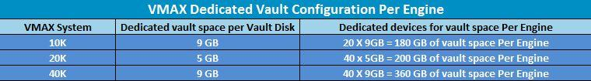
◆All drives types can be used for vault. Vault is supported on EFDs, however if your Enginuity code level is below 5875 configuring Vault devices on Flash drives is not supported although Flash drives are supported at Enginuity 5875 but they require an RPQ. Ideally Vault would be placed on less expensive drives than EFD.
◆ The vault space is for internal use only. No other device can reside in this space.
◆ Five vault drives per loop are required to enable sparing.
◆VMAX 10K – Five drives per loop containing vault devices are required on the first four loops of each engine.
◆ VMAX 20K/40K – Five drives per loop containing vault devices are required on all 8 loops of each engine.
◆ Vault drives are eligible for permanent sparing and direct sparing. For further drive sparing details please refer to the EMC white paper DRIVE SPARING IN EMC SYMMETRIX VMAX FAMILY SYSTEMS
◆ The total capacity of all vault devices in the system will be at least sufficient to keep
two logical copies of the persistent portion of physical memory.
The example below shows how the first five disks in each of the 8 loops for Engine 4 (Directors 7&8) are automatically configured with a vault device:

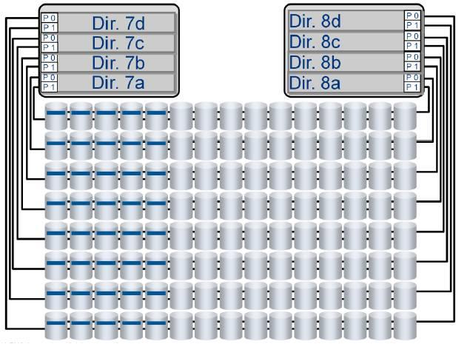

Flash I/O Module: The flash I/O modules are utilized during the vaulting sequence.As cache size has grown, the time required to move all array data to a persistent state has also increased. Vaulting is designed to limit the time needed to power off the system if it needs to switch to a battery supply. Unlike previous platforms, VMAX All Flash and VMAX3 platforms do not vault to backend drives. Data is now vaulted to dedicated I/O modules, known as flash I/O modules, saving disk space. Vaulting to flash also expedites the vaulting process, and centralizes it to the engine components, removing the need for battery backup to disks, creating an overall denser configuration than previous systems.
Vault triggers: State changes that require the system to vault are referred to as vault triggers. There are two types of vault triggers.
- Internal availability triggers: Internal availability triggers are initiated when global memory data becomes compromised due to component unavailability. Once these components become unavailable, the system triggers the Need to Vault (NTV) state, and vaulting occurs. There are 3 types of internal triggers.
a. Vault flash availability — The flash I/O modules are used for storage of meta data under normal conditions, as well as storing any data that is being saved during the vaulting process. When the overall available flash space in the flash I/O modules becomes the same size as N copy of global memory, the NTV process triggers. This is to ensure that all of the data is saved before a potential further loss of vault flash space occurs.
b. Global memory (GM) availability — When any of the mirrored director pairs are both unhealthy either logically or environmentally, NTV triggers because of GM unavailability.
c. Fabric availability — When both the fabric switches are environmentally unhealthy, NTV triggers because of fabric unavailability.
2. External availability triggers: External availability triggers are initiated under circumstances when global memory data is not compromised, but it is determined that the system preservation is improved by vaulting. Vaulting in this context is used as a mechanism to stop host activity, facilitate easy recovery or act as an attempt to proactively take action to prevent potential data loss. There are two external triggers:
a. Engine trigger — When an entire engine fails, the system vaults.
b. DAE trigger — If the system has lost access to the whole DAE or DAEs, including dual-initiator failure, and loss of access causes configured RAID members to become non-accessible, the system vaults.
InfiniBand (IB) module: Dual Infiniband switches (a.k.a., Fabric or MIBE) provide connectivity to the matrix interface board enclosure (MIBE), as part of the Dynamic Virtual Matrix.
Dynamic Virtual Matrix

